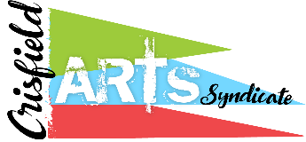
CRISFIELD ARTS SYNDICATE
MEMBERSHIP APPLICATION

MEMBER BENEFITS:

- Opportunity to support the arts and artists
- Advance notice of events and exhibits
- Reduced hanging fees for exhibits
- Reduced fees for classes
- Opportunity to participate in “members only” exhibits
- Opportunity to influence programs offered by the Crisfield Arts Syndicate

ANNUAL MEMBERSHIP FEES:
- Youth (under 18) and Student (incl. college) - $15
- Senior (65 and over) - $25
- Individual - $35
- Family - $50
- Champion Member - $150
- Hero Member - $300
- Super Star Member - $500

Please provide the following information:

Name: __________________________________________________________________

Additional Family Members (if applicable): _____________________________________

________________________________________________________________________

Address: ________________________________________________________________

Primary Phone: _______________________ Alt. Phone: __________________________

Membership Category: _______________________________ Fee Paid: ______________

Application and check made out to Crisfield Arts Syndicate may be mailed to:
Crisfield Arts Syndicate
c/o Trish Kotzen
1638 Bayside Drive
Chester, MD 21619

